***PAAREES PERFUMES***

***DAVIDOFF***

***FOR MEN***

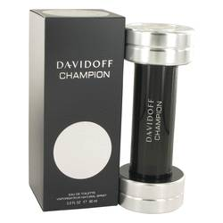

***Davidoff Champion***

***Description:***

Davidoff Champion by Davidoff Cologne. Men who prefer the outdoors scent of cedar will appreciate Davidoff Champion for its aromatic and masculine accords. Top notes of bergamot and fresh lemon give way to a heart of galbanum, and clary sage. Base notes of rich cedar and oak moss deliver a long-lasting fragrance that stays close to the skin for hours. Introduced in 2010 by Davidoff Champion, this light and uncomplicated formula makes an ideal addition to any casual social event.